CN SDN, MININET MINIPROJECT

Name – Shamanth Shekar K SRN – PES1UG24AM258 SECTION – E

Measurement and Analysis of Network Delay Using SDN (Mininet + POX)

1. Introduction
Network latency refers to the time taken for a data packet to travel from source to destination and back. It is commonly measured as Round-Trip Time (RTT). Latency plays a crucial role in determining network performance, especially in real-time applications.
This project focuses on measuring and analysing delay between hosts using ICMP ping in a Software Defined Networking (SDN) environment. By using Mininet and POX controller, different network scenarios are created to study delay variations.

2. Objectives
- To measure network delay using ping (ICMP)
- To record RTT values between hosts
- To compare delay under different network conditions
- To analyze variations in delay using SDN

3. Tools and Technologies Used
- Mininet (Network Emulator)
- POX Controller (SDN Controller)
- Python
- iperf (for generating traffic)
- Linux (Ubuntu VM)

Scenario 1: Normal Network

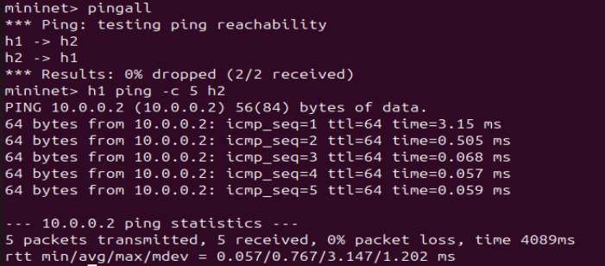

From this we can confer the round-trip time as:
Minimum – 0.057, Average – 0.767, Maximum – 3.147 and Packet Loss – 0%

Scenario 2: Packet drop using SDN

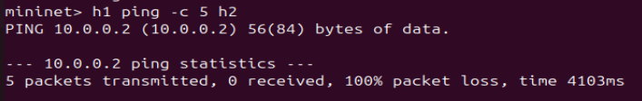
100% Packet Loss and no response for RTT

Scenario | Packets Sent | Received | Packet Loss | Avg RTT | Observation
Normal | 5 | 5 | 0% | Low | Stable network
Drop Mode | 5 | 0 | 100% | — | Packets blocked

In the second scenario, ICMP packets were intentionally dropped using SDN controller rules. This resulted in 100% packet loss, demonstrating how network delay and delivery can be controlled using flow rules in Software Defined Networking.
This experiment shows that SDN provides centralized control over traffic, allowing dynamic modification of network behaviour such as delay and packet delivery.

Scenario 3: Network Load (Congestion)

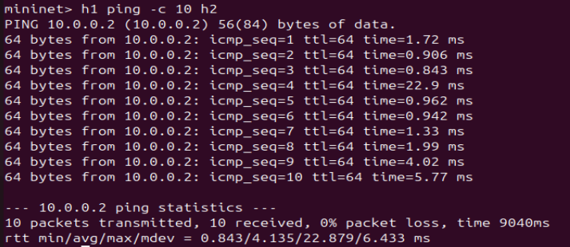

This is the result with load (iperf) where the round-trip time is:
Minimum – 0.843, Average – 4.135, Maximum – 22.879 but still 0% Packet Loss

When network traffic was increased using iperf, the RTT values increased due to congestion, demonstrating delay variation under load.

When ICMP packets were dropped using SDN controller rules, packet loss reached 100%, showing how SDN can control packet delivery and delay.

5. Results
Scenario | Packets Sent | Packets Received | Avg RTT | Packet Loss | Observation
Normal Network | 5 | 5 | ~0.7 ms | 0% | Stable network
With Load (iperf) | 10 | 10 | ~4 ms | 0% | Slight delay increase
Packet Drop (SDN) | 5 | 0 | — | 100% | No communication

